SPH3U Assessment – Topic 1 -Measurement Name:

- Write the following in normalized scientific notation, include appropriate significant figures (3 marks).

- 40,168,000,000 (b) 0.000 006 088 (c) 345.624

- Calculate the following without the use of a calculator; significant figures are NOT required. (6 marks)

- 65,000,000 x 2,000,000 (b) 140,000,000 x 0.00005 (c) 0.000004 x 0.000011

- State the number of significant figures in the following: (3 marks)

- 4,009.05 (b) 0.0010003 (c) 4.0050

- Evaluate the following and maintain the appropriate number of significant figures (4 marks)

- 8.45 + 1.6 – 3.25 + 2 (b) 4.888 x 0.1

- Using a ruler, measure the length of the nail AND state the absolute error with your measurement Justify/explain your error decision. (3 marks).

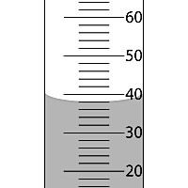
- State the volume (mm) of water in the picture of the graduated cylinder, include the absolute error with your measurement. Justify/explain your error decision.
(3 marks)

- A student records a measurement of a frog’s horizontal jump distance as 25cm ± 2cm. (2 marks)

- What is the absolute error of the measurement?

- What is the percentage error of the measurement?

