SNC2D Task – Climate Factors Name:
- Match each key term in the left column with its definition in the right column. You many need your textbook, Chapter 8 to assist you with some of the definitions.
Term | Letter | Definition
A. system |  | energy that travels as waves that move outward in all directions from a source; includes infrared radiation, ultraviolet radiation, radio waves, X rays, gamma rays, and visible light
B. feedback loop |  | a process that removes greenhouse gases from the atmosphere
C. electromagnetic radiation |  | a description of the total energy exchange within a system; a summary of how energy from the Sun enters, moves through, and leaves the Earth system
D. thermohaline circulation |  | the increased capacity of the atmosphere to absorb and prevent the escape of thermal energy because of an increase in greenhouse gases introduced by human activities
E. energy budget |  | a part of a biogeochemical cycle in which matter or energy accumulates; also called a reservoir
F. concentration |  | a group of interdependent parts that work together to form a single, functioning whole
G. parts per million (ppm) |  | the ability of a substance to warm the atmosphere by absorbing thermal energy
H. greenhouse gas |  | the process by which atmospheric nitrogen is changed into forms that can be used by plants and other organisms
I. sink |  | the relative amounts of carbon in different stores; also an accounting of the exchanges (incomes and losses) of carbon between the stores of the carbon cycle
J. ozone |  | a natural process that exchanges matter and energy between the abiotic environment to the biotic environment and back
K. chlorofluorocarbon (CFC) |  | a three-dimensional pattern of ocean circulation driven by wind, heat, and salinity that is an important component of the ocean–atmosphere climate system
L. anthropogenic greenhouse effect |  | a process in which part of a system’s output is returned, or fed back, to the input
M. global warming potential (GWP) |  | a human-made chemical compound that contains chlorine, fluorine, and carbon; when released into the atmosphere may cause depletion of the ozone layer
N. biogeochemical cycle |  | the amount of a particular substance in a specific amount of another substance
O. store |  | a greenhouse gas that is composed of three atoms of oxygen; it is commonly found in a concentrated layer in the stratosphere
P. global carbon budget |  | a gas in Earth’s atmosphere that absorbs and prevents the escape of radiation as thermal energy; examples include carbon dioxide and methane
Q. nitrogen fixation |  | a unit of measurement that indicates the number of parts of a substance per million parts of another substance;
- Use the words provided to complete the following statements.
system  feedback loops  energy budget | concentration  biogeochemical cycles  stores | nitrogen fixation  greenhouse gases  global warming potential (GWP)
1. ________________________ can be measured in parts per million. (8.2)
2. Earth is an example of a closed ________________________. (8.1)
3. A(n) ______________ ______________ describes the total energy exchange within a system. (8.1)
4. Methane has a higher ____________ ____________ ___________ than carbon dioxide. Scientists are
concerned about increased methane, produced by cattle, in our environment. (8.2)
5. Through the process of ______________ ______________, nitrogen is changed into forms that living
things can use. (8.3)
6. Carbon dioxide, water vapour, and methane are all examples of _____________ ____________. (8.2)
7. Energy and matter move through reservoirs in the Earth system as part of several
________________ ________________. (8.3)
8. Matter can be stored in reservoirs, also called ________________________, for a few minutes to
many million years. (8.2)
9. ________________ ________________ may increase or decrease the effect of one small change on
a biogeochemical cycle. (8.1)

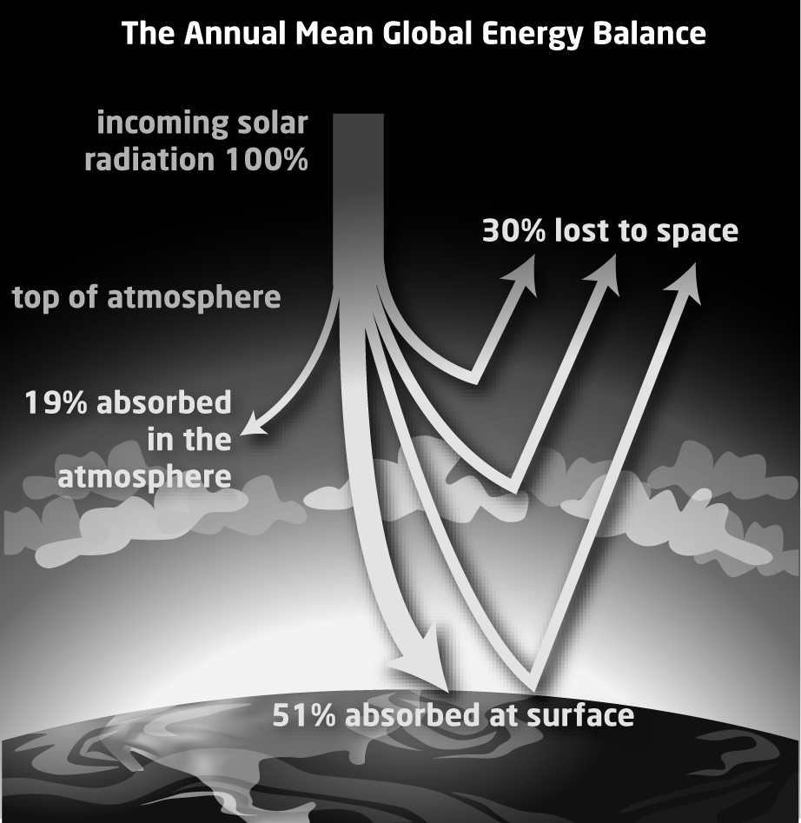
- The diagram below shows what happens to most of the solar energy that enters the Earth system.

- What percentage of solar energy is lost to space?

- What percentage of solar energy is absorbed at Earth’s surface?

c. Is more solar energy currently absorbed at the poles or at the equator? Explain your reasoning.

- The graph below shows carbon dioxide concentrations in Earth’s atmosphere as measured at Mauna Loa, in Hawaii.
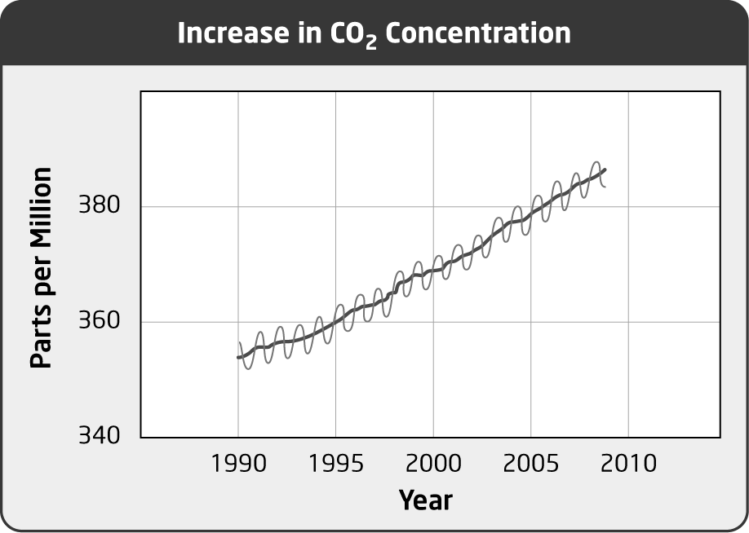
a. Why do you think the concentration of carbon dioxide has a peak each year?

b. Why do you think the concentration of carbon dioxide has a low point each year?

c. How have carbon dioxide concentrations changed on average since 1990?

- List the five main stores in the carbon cycle.

1. _______________________________________________________________________________
2. _______________________________________________________________________________
3. _______________________________________________________________________________
4. _______________________________________________________________________________
5. _______________________________________________________________________________

