SNC2D1 Task – Circulatory System Name:

1. There are three blood vessels in the body: *arteries, veins,* and *capillaries*.

a) Identify the blood vessel that best represents each diagram. **(3 marks)**

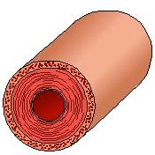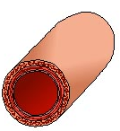

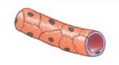

______________________ ______________________ ______________________

b) Identify that blood vessel associated with each description/function. **(9 marks)**

______________________ Carry blood towards the heart.

______________________ Have very thin walls.

______________________ Carry blood under high pressure.

______________________ Carry blood away from the heart.

______________________ Link arteries and veins together.

______________________ Contain valves ensuring blood flows in one direction.

______________________ Have thick muscular walls.

______________________ Carry blood under low pressure.

________________________ Exchange gas, nutrients, and wastes with tissue cells.

1. Which protein is found in red blood cells that allows oxygen and carbon dioxide to bind and travel through the body?
2. Which blood vessels contain valves? What are the functions of these valves?
3. a) Use the word bank below to correctly label the different parts of the heart.

Label the terms by inserting text boxes or writing them by hand.

Highlight the two heart chamber **terms** that carry oxygenated blood red.

Highlight the two heart chamber **terms** that carry deoxygenated blood blue.

|  |  |  |
| --- | --- | --- |
| * aorta * descending aorta * left atrium * right atrium * left pulmonary artery | * right pulmonary artery * left pulmonary veins * right pulmonary veins * inferior vena cava * superior vena cava | * left ventricle * right ventricle * septum |

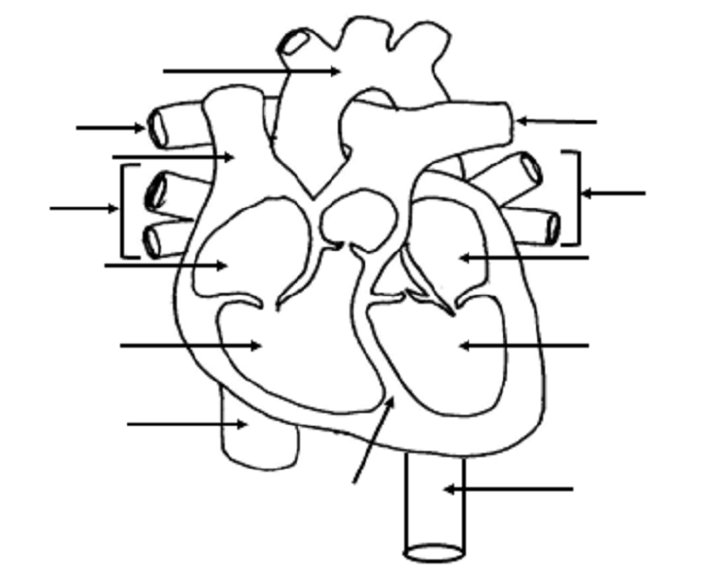

b) What is the main function of the *septum* in the heart? Be specific and descriptive.

1. a) Draw arrows to show the flow of blood through the heart. Use red arrows ( **🡪** ) to represent oxygenated blood and blue arrows ( **🡪** ) to represent deoxygenated blood.

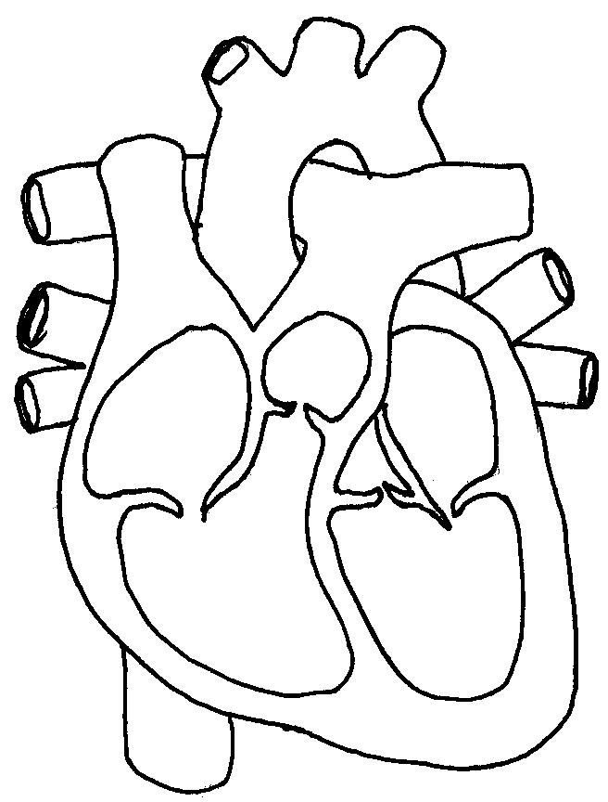

**#1**

**#1**

**#2**

**#2**

**#3**

**#4**

**#4**

b) Answer the following questions based on your labelled heart diagram above.

For the structures identified **#1**, where is the blood going to? **Why**?

For the structures identified **#2**, where is the blood going to?

For the structure identified **#3**, where is the blood going to?

For the structures identified **#4**, where is the blood going to? **Why**?

1. Starting from and ending with the *right atrium*, trace the flow of blood through the heart and body by the numbering (#1-10) the following in the correct order. I started it for you.

___**1**__ right atrium ______ lungs

______ left atrium ______ right ventricle

______ pulmonary artery ______ left ventricle

______ vena cava ______ body cells

______ aorta ______ pulmonary veins