SNC2D1 Task – Respiratory System Name:

- Describe the two primary functions of the respiratory system. Be specific and descriptive and write in complete sentences. This will require research. (2 marks)

1.

2.

- The main organs of the respiratory system are listed in the word bank below. Correctly label these organs in the following two diagrams of the respiratory system.

Note: Organs from the word bank can be used more than once.

- alveoli  - left bronchus  - right bronchus  - bronchioles | - diaphragm  - epiglottis  - larynx | - left lung  - right lung  - oral cavity | - nasal cavity  - pharynx  - trachea
Diagram #1:

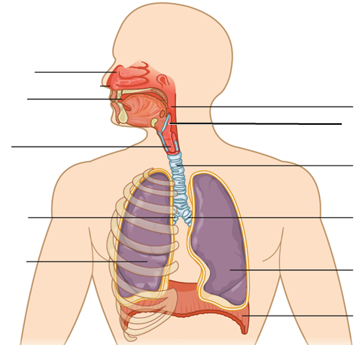

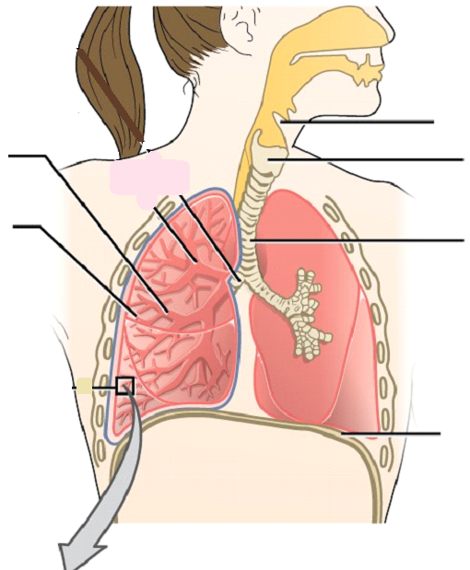
Diagram #2:
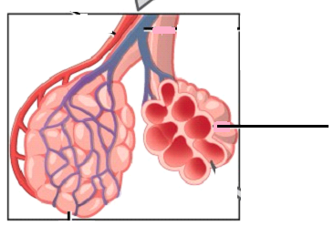

- Match each organ of the respiratory system with the correct function and description. This will require research. (9 marks)

______ Nasal cavity A. Contains two bands of tissue (vocal cords) that vibrate when air
passes through to produce sound. Also called the voice box.

______ Pharynx B. The two tubes that branch from the trachea and allow inhaled
air to enter both lungs.

______ Larynx C. Covers the entrance to the larynx during swallowing to prevent
food and liquid from entering the trachea.

______ Epiglottis D. The band of muscle found below the lungs that contracts and
relaxes during breathing.

______ Trachea E. Hollow space behind the nose lined with cilia and mucus that
warms, moistens, and filters air particles.

______ Bronchi F. Air sacs found at the ends of the bronchioles. Where gas
exchange takes place.

______ Bronchioles G. The tube that allows inhaled air to enter the lower respiratory
tract. Also called the windpipe.

______ Alveoli H. Smaller tubes found inside the lungs that bring inhaled air to the
alveoli.

______ Diaphragm I. Area where both inhaled air and swallowed food passes through.
Also known as the throat.

