SNC2D1 Task – Digestive System Name:

- The main function of the digestive system is for digestion and absorption.

What does digestion involve?

What does absorption involve

- The main organs of the digestive system are listed in the word bank below. Correctly label these organs in the following diagram of the digestive system. This will require research. (16 marks)

Note: You can label by inserting text boxes or writing them by hand.

- liver  - mouth  - stomach  - appendix | - salivary glands  - teeth  - pancreas  - small intestine | - epiglottis  - rectum  - gall bladder  - pharynx | - esophagus  - anus  - large intestine  - tongue
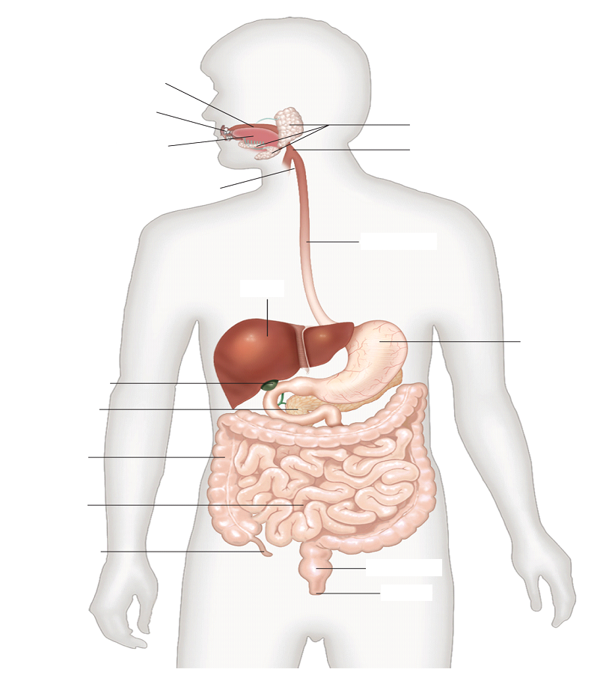

- Match each organ of the digestive system with the correct function and description. This may require research

______ salivary glands  ______ mouth  ______ teeth  ______ pharynx  ______ epiglottis  ______ tongue  ______ esophagus  ______ liver  ______ stomach  ______ pancreas  ______ gall bladder  ______ small intestine  ______ large intestine  ______ appendix  ______ rectum  ______ anus | - Mixes food. Begins digestion of proteins.  - Elimination (removal) of feces.  - Where the physical breakdown of food begins. It also begins the chemical breakdown of carbohydrates.  - Stores bile.  - Absorbs water and minerals into the bloodstream. Where feces is formed.  - Secretes saliva which contains enzymes, such as amylase, that initiate digestion of carbohydrates.  - Produces and releases enzymes into the small intestine for the digestion of food.  - Its function is unknown. One theory is that it protects the good bacteria in the gut.  - Involved in the chewing and breaking down of food.  - Uses muscle contractions, called peristalsis, to push food down into the stomach.  - Regulates (controls) the elimination of feces.  - Produces bile. Breaks down fats into smaller droplets.  - Prevents food from entering the trachea and into the lungs during swallowing.  - Digestion of food is completed. Where most of the nutrients are absorbed into the bloodstream.  - Moves food around and allows the food to mix with the saliva.  - Connects the mouth and esophagus. It is also a pathway for air to enter the trachea.

- a) What are accessory organs?

b) Name five accessory organs of the digestive system.

