**DNA - The Double Helix**

Recall that the ***nucleus*** is a small spherical, dense body in a cell.  It is often called the "control center" because it controls all the activities of the cell including cell reproduction, and heredity.

***Chromosomes*** are microscopic, threadlike strands composed of the chemical DNA (short for deoxyribonucleic acid).  In simple terms, DNA controls the production of proteins within the cell.  These proteins in turn, form the structural units of cells and control all chemical processes within the cell.  Think of proteins as the building blocks for an organism, proteins make up your skin, your hair, parts of individual cells. The proteins that are made are determined by the sequence of DNA in the nucleus.

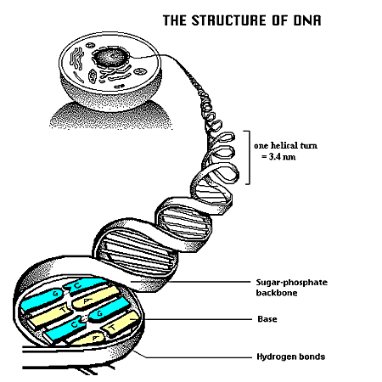Chromosomes are composed of ***genes***. Genes are segments of DNA that code for particular proteins which in turn code for specific traits (for example the gene for baldness or the gene for blue eyes).  Meanwhile, ***DNA*** is the chemical that genes and chromosomes are made of. DNA is called a ***nucleic acid*** because it was first found in the nucleus.  DNA is also found in organelles, the mitochondria and chloroplasts, though it is the DNA in the nucleus that actually controls the cell's workings.

*Refer to DIAGRAM to colour*:

In 1953, James Watson and Francis Crick established the structure of DNA.  The shape of DNA is a ***double helix***, which is like a twisted ladder. The sides of the ladder are made of alternating sugar and ***phosphate*** molecules.  The sugar is ***deoxyribose***.

The rungs of the ladder are pairs of 4 types of ***nitrogen bases***.  The bases are known by their coded letters ***A, G, T, C***.   These bases always bond in a certain way.  ***Adenine*** will only bond to ***thymine***.  ***Guanine*** will only bond with ***cytosine***. This is known as the ***"Base-Pair Rule".*** The bases can occur in any order along a strand of DNA. The order of these bases is the code that contains the instructions. For instance ATGCACATA would code for a different gene than AATTACGGA. A strand of DNA contains millions of bases. (For simplicity, the image only contains a few.)

Note that that the bases attach to the sides of the ladder at the sugars and not the phosphate.

The DNA helix is actually made of repeating units called ***nucleotides***. Each nucleotide consists of three molecules: a sugar (deoxyribose), a phosphate which links the sugars together, and then one of the four bases. Two of the bases are double ringed purines - adenine and guanine.  The single ringed pyrimidines are thymine and cytosine.

The two sides of the DNA ladder are held together loosely by ***hydrogen bonds***. The DNA can actually "unzip" when it needs to replicate - or make a copy of itself. DNA needs to copy itself when a cell divides, so that the new cells each contain a copy of the DNA. Without these instructions, the new cells wouldn't have the correct DNA “blueprint”.

**The Blueprint of Life**

Every cell in your body has the same "blueprint" or the same DNA. Like the blueprints of a house tell the builders how to construct a house, the DNA "blueprint" tells the cell how to build the organism.   Yet, how can a heart be so different from a brain if all the cells contain the same instructions?   Although much work remains in genetics, it has become apparent that a cell has the ability to turn off most genes and only work with the genes necessary to do a job.  We also know that a lot of DNA apparently is nonsense and codes for nothing.  These regions of DNA that do not code for proteins are called "***introns***", or sometimes "***junk DNA***". The sections of DNA that do actually code for proteins are called "***exons***".

**DNA - The Double Helix -- Questions**

1. Write out the full name for DNA. ________________________________________________
2. What are CHROMOSOMES? __________________________________________________
3. What is a gene? ____________________________________________________________
4. What does DNA do, “in simple terms”? ___________________________________________
5. Where in the cell are chromosomes located? _______________________________________________________
6. DNA can be found in what two organelles (other than the nucleus)? _________________________________________________________
7. Where in the cell are proteins made/built? ________________________________
8. What two scientists established the structure of DNA? ________________________________
9. What is the shape of DNA? ______________________________________
10. What sugar is found in DNA? _______________________
11. What are the sides of the DNA “ladder made” of? ____________________________________
12. What are the "rungs" of the DNA “ladder” made of? _______________________________________________________
13. How do the bases bond together?   A  bonds with  _____      G  bonds with  _______

🡪 what is this pattern of pairing know as? ________________________________

1. If one “side” (or, “STRAND”) of DNA contains the bases ATGGCCTTA, then the other side of the DNA molecule would have bases in the order: ___________________
2. The two “sides” of the double helix are held together by ___________________________ (between the “complementary” base pairs)
3. DNA is made of repeating units called _____________________________; which are each made up of ______________________________________________.
4. Why is DNA called the "Blueprint of Life"?
5. What is “junk DNA”?
6. How do some cells become brain cells and others become skin cells, when the DNA in ALL the cells is exactly the same.  In other words, if the instructions are exactly the same, how does one cell become a brain cell and another a skin cell?

|  |  |
| --- | --- |
| http://www.biologycorner.com/resources/DNA-plainBW-DP.gif**DNA - The Double Helix**  Note the “twist” in the double helix at this point | Color the DNA components using the i instructions below:  **Color all the phosphates pink (one is labeled with a "P").**  **Color all the deoxyribose sugars blue (one is labeled with a "D")**.  **Color the thymines orange. http://www.biologycorner.com/resources/thymine.gif**  **Color the adenines green. http://www.biologycorner.com/resources/adenine.gif**  **Color the guanines purple. http://www.biologycorner.com/resources/guanine.gif**  **Color the cytosines yellow.** http://www.biologycorner.com/resources/cytosine.gif |
| **Color the HYDROGEN BONDS red.**  **Identify each nucleotide below.**  **Color the nucleotides using the same colors as you colored them in the double helix.** |

