SNC2D1 Task – Identification Diagrams Name:

This worksheet will apply your knowledge and understanding of Animal and Plant cells, and the organelles found in these types of cells. Please note, some research will be required.

- Correctly name each cell organelle identified. (12 marks)

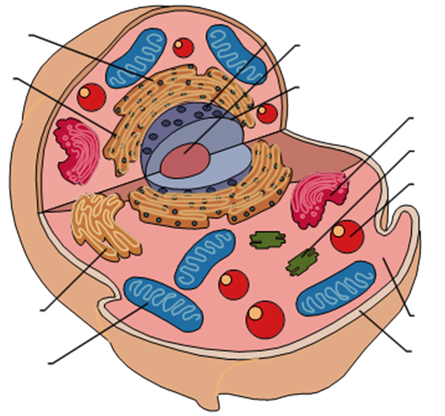
B.
I.

H.
(dot)
A.

E.

G.

K.

C.
F.

J.
D.

- __________________________________ G. ____________________________________

- __________________________________ H. ____________________________________

- __________________________________ I. ____________________________________

- __________________________________ J. ____________________________________

- __________________________________ K. ____________________________________

- __________________________________ Type of cell: ___________________________

- Name two organelles that were not identified in #1. (2 marks)

___________________________________________________________________________

- Correctly name each cell organelle identified. (12 marks)

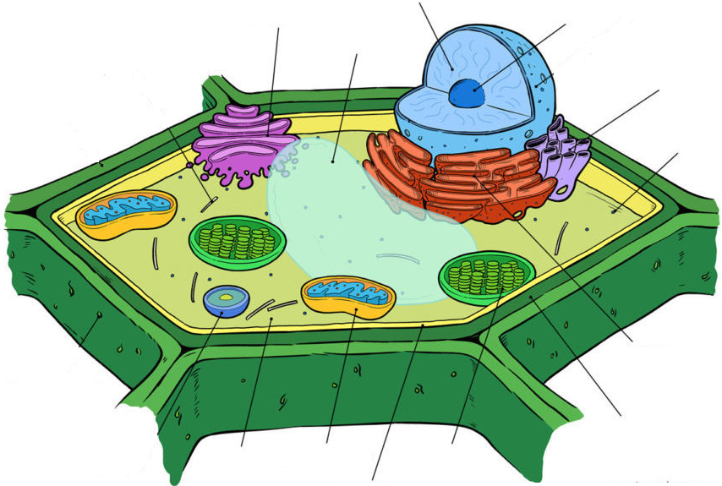
I.
D.
B.
G.

K.

F.

H.

C.

E.
A.
J.

- __________________________________ G. ____________________________________

- __________________________________ H. ____________________________________

- __________________________________ I. ____________________________________

- __________________________________ J. ____________________________________

- __________________________________ K. ____________________________________

- __________________________________ Type of cell: ___________________________

