SNC2D Task – Systems Summary /34 marks

Please read the instructions carefully and answer each question in the space provided.

- Watch the video Human Body Systems Functions Overview by clicking on the following link:
https://www.youtube.com/watch?v=gEUu-A2wfSE
After watching the video, answer the following questions.

- Match each body system with the correct function. (11 marks)

A. Digestive system | _____ Helps the body fight bacteria and viruses.
B. Circulatory system | _____ Co-ordinates voluntary and involuntary actions.
C. Respiratory system | _____ Breaks down food and absorbs nutrients for all  cells of the body.
D. Excretory system | _____ Allows for movement.
E. Integumentary system | _____ Produces and releases hormones that help  maintain body function.
F. Nervous system | _____ Important in the production of new offspring.
G. Muscular system | _____ Pumps and carries blood throughout the body to  deliver oxygen and nutrients.
H. Immune system | _____ Provides support and protects internal organs.
I. Reproductive system | _____ Produces and releases urine which removes waste  from the body.
J. Endocrine system | _____ Important for gas exchange: oxygen in, carbon  dioxide out.
K. Skeletal system | _____ Made up of your skin which protects your internal  organs and helps maintain body temperature.

- How many bones are in the human body? _______________ (1 mark)

- In humans, what is the largest organ? __________________ (1 mark)
- Below are the 11 organ systems of the human body. Identify the organ system that each diagram represents. I have provided a word bank. (11 marks)

Nervous system  Immune system  Endocrine system | Digestive system  Muscular system  Reproductive system | Excretory system  Skeletal system  Respiratory system | Integumentary system  Circulatory system

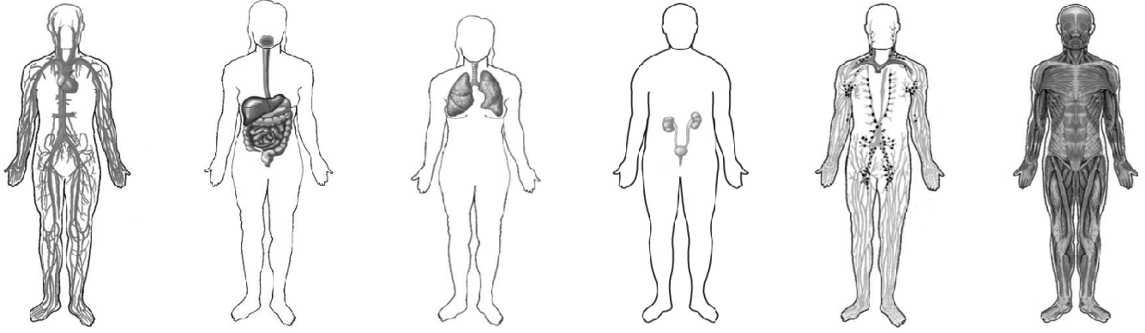

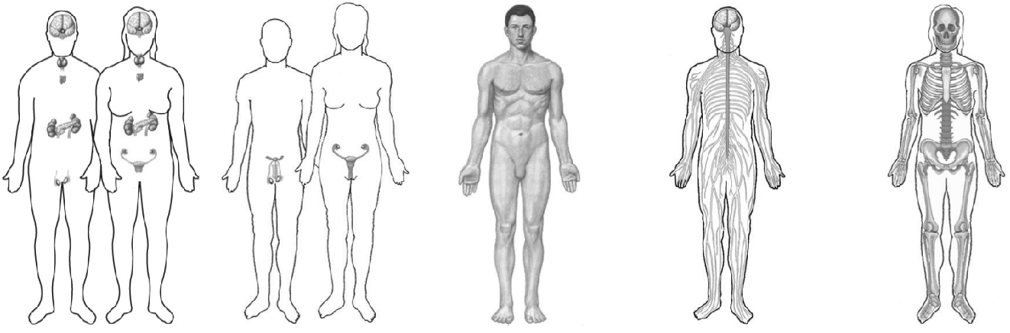

- The organs of some of the organ systems are listed in the first column of the chart. For each organ listed, place a check (√ ) under the organ system(s) to which it belongs. This will require research. The video will also be helpful. (10 marks)

Hint: There are organs below that belong to more than one organ system and will require more
than one check (√ ).

ORGANS | ORGAN SYSTEMS
 | Digestive  system | Respiratory  system | Excretory  system | Reproductive  system | Circulatory  system | Nervous  system | Endocrine  system | Skeletal  system
Large
intestine
Bladder
Brain
Ovaries
Nose
Liver
Veins
Kidneys
Spinal cord
Lungs
Heart
Small
intestine
Mouth
Bone
Trachea
Esophagus
Skin
Testes
Stomach
Pancreas

