What is Light?
What is Light?
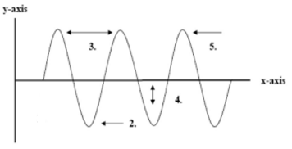
Light is energy given off in waves. These waves are made up of energy carrying particles called _________. Though some light can be seen by the human eye, most is invisible.
Wave terminology (Match with Diagram)
Amplitude:
Wavelength:
Crest:
Trough:

Light Waves

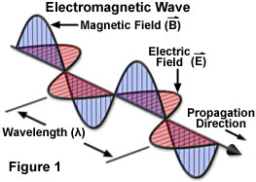
Light waves are more complicated than the simple wave in the simulator. _______ are small bundles of energy that produce ________ and ________ fields. These field oscillate in a special type of wave - an _____________ wave.
The energy contained in these waves is also known as electromagnetic radiation. Light in a vacuum always travels at a speed of 3.0x10⁸ m/s, or 300,000,000 m/s - according to the theory of relativity nothing can travel faster than this speed.

The Electromagnetic Spectrum
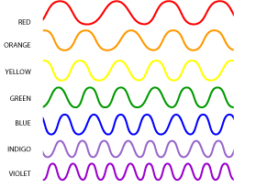
There are _________ forms of light. They are all made of photons, travelling in _________________________, at the same ______ in a vacuum, but they have different ______________________ - these different forms of light make up the electromagnetic spectrum. The ___________ the wavelength, the more _______________the light.
Visible Light
The different _______ of the visible spectrum are created by photons of different ___________ (ranging from 400 nm to 700 nm). When you see an object of a given colour, it is because that object is directing photons of a given wavelength into your eyes.
So, what wavelength is white?
What about black?

White Light
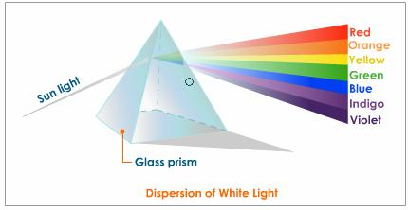
White light, and so the colour white, is the result of a ___________ of photons of all the colours of the visible spectrum.
If you direct white light through a Prism the white light will separate out Into its constituent colours - this is known as __________.
The colour black is the _______ of photons in the visible spectrum.

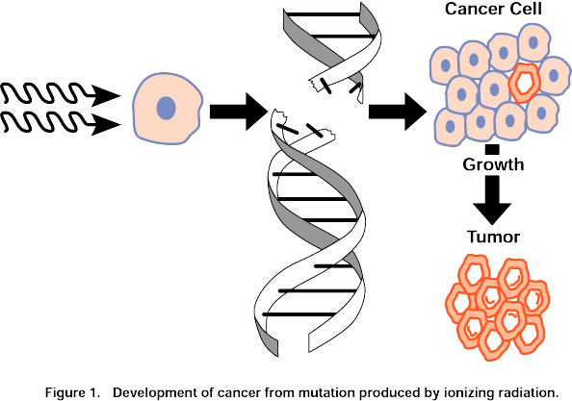
Dangerous Light
The shorter the wavelength, the more energy the light possesses. Generally light with wavelengths shorter than visible light can be dangerous, with gamma rays being the most dangerous.
EM radiation can be divided into ionizing radiation which has the ability to ______ electrons from atoms or molecules (gamma rays, x-rays and some UV light), and ___________ radiation which cannot free _________ from atoms or molecules.

