Task – Survey

This task is not about the content, but IS about the process of following instructions and submitting properly.
Type as much as you need to, if the answer spill over to two pages, that is fine. The space provided is not an indication of your answer size.

- Type your name here.

- Identify what technology you have available to you on a regular basis: (scanner, printer, pc computer, mac computer, digital camera, smartphone, tablet, etc.). This information will help me make suggestions to you regarding how you can submit your work if you are having troubles. No one else will see the results of this Task.

- Please share any challenges you have faced/overcome with respect to the online component of learning in high school.

- What strategies work BEST for YOU, either online or in person, to help you learn. List anything that comes to mind.

- Is there anything I should know about, at this point in time, that may affect your ability to do course work (online or in person)?

- Save this document by using the “SAVE AS” command in the menu above (under File). Place your name at the end of the “filename”, ie Task-Survey-Ryan,
AND
Change the filetype to PDF
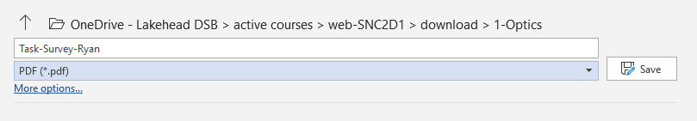
- Submit the completed PDF file in Edsby, using the MY WORK tab, and the online submission button.

